**Periodontal Plastic and Aesthetic Surgery**

**Part 2 Dr. Huda Jasim Jebur**

**2.Problems associated with excessive gingival display**

Excessive gingival display (i.e., gummy smile) is an aesthetic concern for many patients. This appearance may be caused by a skeletal problem called vertical maxillary excess, by dentoalveolar extrusion, or by incomplete exposure of the anatomic crown, often referred to as altered passive eruption. It can be associated with a short upper lip or excessive lip translation. A combination of causative factors can require more than one treatment option.

If the cause of the gummy appearance is incomplete exposure of the anatomic crown, the teeth will appear short and unattractive as in **altered or delayed passive eruption.**

Ideally, the **width-to-length ratio** of a maxillary central incisor clinical crown should fall between 0.78 and 0.85. A central incisor with a width of 8.5 mm should have a length between 10 and 11 mm. The length of the maxillary canine is equal to or slightly less than the central incisor, and its **gingival margin should be aligned with the central incisor gingival margin**. The gingival margin of the lateral incisor is usually about **1.0 mm coronal** to the margins of the adjacent teeth.

**-Surgical Technique**

Exposure of the full anatomic crown is necessary to achieve a smile with minimal gingival exposure. Measurements before surgery should include **clinical crown width and length, anatomic crown length, and height of keratinized tissue.**

Surgical crown lengthening can be accomplished by soft tissue excision alone or by flap surgery with or without osseous surgery. Determinates for choice of a surgical procedure are **(1) the need to leave a minimum of 3.0 mm of keratinized marginal tissue and (2) the possible need for osseous surgery**. If excision of soft tissue for full anatomic crown exposure would leave at least 3.0 mm of keratinized marginal tissue, there is no need for osseous surgery, and soft tissue excision alone is the treatment of choice. If less than 3.0 mm of keratinized marginal tissue would remain after the necessary excision, an apically positioned flap is required.

**-Osseous Surgery**

The facial soft tissue margin is located approximately 3 mm coronal to the osseous crest, allowing 2 mm for biologic attachment and 1 mm for sulcus depth. Failure to adjust bone form and level to account for these dimensions leads to rebound of surgically reduced soft tissue to reform this biologic width. Precise osseous surgery is best accomplished after elevation of a full-thickness mucoperiosteal flap that provides good visibility and access for three-dimensional ostectomy and osteoplasty. Creation of an ideal osseous form leads to predictable and stable soft tissue position and ideal crown exposure.



**3.Problems associated with interdental papillary loss**

Loss of the interdental papilla is a major aesthetic problem for many patients. It is often referred to as the **black triangle or hole**. Reconstruction of the lost or reduced interdental papilla is the most difficult and unpredictable problem in aesthetic periodontal therapy.

Interdental papilla is gingival tissue **supported and created** by two adjacent teeth in contact and the underlying bone beneath this tissue. The **loss of bone** as the result of periodontal disease or the **loss of the contact** alters the support of the interdental tissue, which can lead to the loss or reduced height of the papilla.

Tarnow, stated **the distance from the crest of the interdental bone to the apical portion** of the contact above this bone determines whether the interdental papilla is absent or present, when the distance from the contact point to the interproximal osseous crest is 5 mm or less, there is complete fill of the gingival embrasures with an interdental papilla. For every 1 mm above 5 mm, the chance of complete fill is progressively reduced by 50%.

**Papilla reconstruction**

**Semilunar coronally repositioned flap:** Approach reported by Tarnow. In their modification for papilla reconstruction, they recommended placing the semilunar incision in the interdental region. Intrasulcular incisions are also made around the mesial and distal half of the two adjacent teeth to free the connective tissue from the root surfaces to allow the coronal displacement of gingivo-papillary unit. To maintain position, the measured amount of the sub epithelial connective tissue obtained from the palate is stuffed further into the semilunar incision and in to the pouch like space coronal to the incision.

**4.Gingival pigmentation**

is a discoloration of the gingiva due to a variety of lesions and conditions associated with several endogenous and exogenous etiologic features.

**Classification of gingival pigmentation**

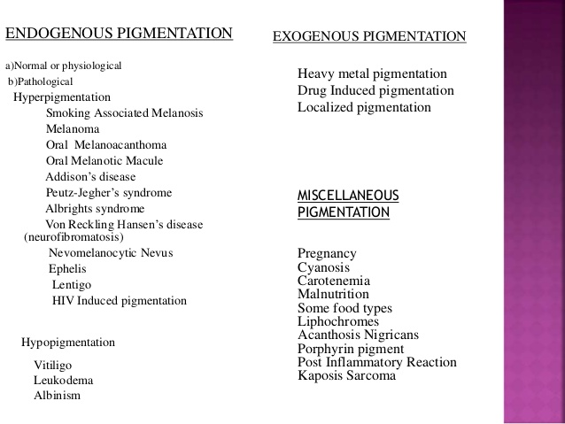

**Gingival Depigmentation Techniques**

1. Scalpel technique

2. Bur abrasion

3. Cryosurgery

4. Electrosurgery

5. Free gingival graft

6. Acellular dermal matrix

7. Laser

**1.Scalpel technique**

Remove the pigmented gingival epithelium and a layer of the underlying connective tissue by splitting the epithelium with blade. Then cover the surgical site with periodontal dressing for 7–10 days.

-Advantages

a) One of the most economic techniques.

b) Healing period for scalpel wounds is faster than other techniques.

**2.Bur abrasion technique**

Diamond bur is used at high speeds to denude the epithelium. The procedure requires (45 min - 1hour) for completion.

-Advantages

a) Simple, safe, non-aggressive method and easy to perform.

b) Less discomfort and is esthetically acceptable to the patients.

c) Does not require any sophisticated equipment/ economical.

-Disadvantages

a) Difficulty in controlling the depth of de-epithelialization.

b) Bleeding and post-operative pain are anticipated.

**3.Electro-surgery**

-Advantages

a) Control hemorrhage.

b) Causes less discomfort to patient.

c) Less scar formation and lesser chair time.

-Disadvantages

a) More expertise than scalpel surgery.

b) Prolonged or repeated application of current to tissue induces heat accumulation and undesired tissue destruction.

c) Avoid contact with periosteum or alveolar bone and vital teeth.

**5.Cryosurgery**

-Advantages

a) Easy and rapid to apply.

b) Does not require anesthesia or suturing or pack.

c) Does not cause any bleeding or scars.

-Disadvantages

a) Followed by swelling.

b) Depth control is difficult.

c) Optimal duration of freezing is not known but prolonged freezing increases tissue destruction.

**5.Free gingival graft**

For treatment of severe physiologic melanin pigmentation requiring replacement with an unpigmented free gingival autograft.

-Advantage

The result of this procedure showed no evidence of repigmentation even after 4.5years. Of the 10 treated patients only 1 patient showed repigmentation after 1 year.

-Disadvantage

a) Patient discomfort due to second surgical site (donor site).

b) Poor tissue color matching at the recipient site .

**6.Acellular dermal matrix allograft (ADMA)**

-Advantages

a) Successfully used in the elimination or greater reduction of gingival melanin pigmentations.

b) Decreased postoperative complications.

c) Unlimited amount of graft material.

d) Predictable and satisfactory esthetic result.

-Disadvantage

Expensive and requires clinical expertise.

**7.Laser**

-Advantages

a) Easy handling.

b) Short treatment time.

c) Hemostasis.

d) Decontamination, and sterilization effect.

-Disadvantages

a) Delayed wound healing.

b) Thermal damage.

c) Deep penetration.

d) Costly.

**5-Problems associated with aberrant frenum**

Discussed in previous lectures (Periodontal Surgery).

**6-Double lip**

Double lip is an infrequent anomaly involving either or both but mainly the upper lip. It is characterized by the presence of a fold of excess or redundant hypertrophic tissue on mucosal side of the lip caused by excessive areolar tissue and non-inflammatory labial mucous gland hyperplasia. It can be congenital or acquired.

The mass demarcated and excised by transverse elliptical incisions from both commissures to the midline using sharp dissection taking care that normal lip tissue is not excised to avoid loss of lip dimension postoperatively. The surgical site then closed using sutures.

"**The future belongs to those who believe in the beauty of their dreams."**

**-Eleanor Roosevelt**